**A guide to installing Moldtrax SQL locally**

First, take the .bak file we will send you and restore that on your server.

Next, run this embedded script on your SQL Server to create server credentials. Double click on the file below and the script should open in your SQL server management studio.



You can set your own user name and password. For password, please choose a strong password with alpha-numeric and special character. Also, provide the database name you want to get access.

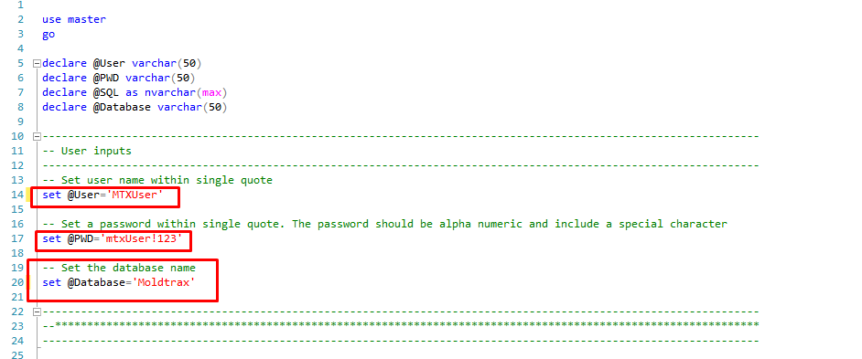

Now, you’re done with SQL Server. Next, set up the Access database. This step can be done by the Moldtrax user if they have the correct SQL credential information from the SQL Administrator.

When the Access database opens, the following screen will open.

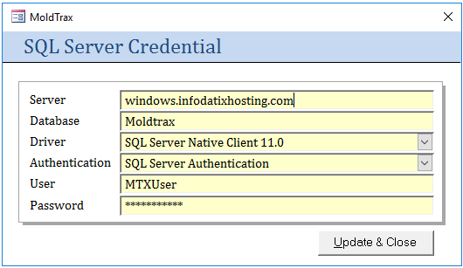

**Server**: Enter the server name. You will get it from SQL server logon screen. Sometimes it includes a domain and a slash and the serer name, sometimes just a server name.

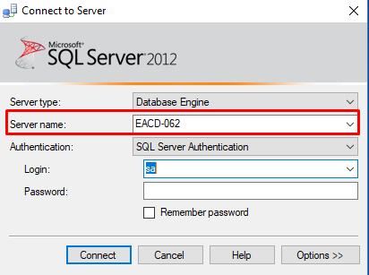

Database: Enter the database name you gave it in SQL Server.

Driver: use SQL Server by default. If you know you have the Native client installed, you can select that. If you have no driver, the program will guide you to a website where to download a SQL driver.

Authentication: Choosing SQL Server authentication and using the username and password you set up earlier is the easiest way to do it. But if you want to control things via Windows authentication, you can choose to do that. But then you need to administer the Windows accounts. For added security, Moldtrax is set up with its own custom user authentication within the program.

User and Password: This is required for SQL Server Authentication option.